1.

C Program:

1 #include<stdio.h>
2 void main(){
3 float amt=0,final;
4 int disc=0;
5 do{
6 printf("Enter Total Amount(Non Negative): ");
7 scanf("%f",&amt);
8 }
9 while(amt<0);
10 if(amt>15000){
11 disc=5;
12 if(amt>=20000){
13 disc=10;
14 if(amt>=30000){
15 disc=15;
16 if(amt>=40000){
17 disc=20;
18
19 }
20 }
21 }
22 }
23 final=amt-(amt*disc/100);
24 printf("Congrats you recieved a Discount of %d %%\n",disc);
25 printf("Final Amount after Discount is : %0.2f\n",final);
26 }

Input/Output:
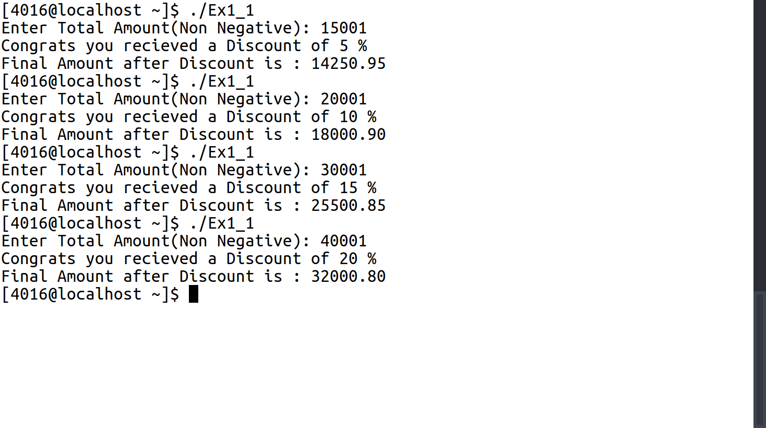

2.

C Program:
1 #include <stdio.h>
2 void main(){
3 int choice=1, balance = 0, change;
4 while(balance>=0 && choice!=0){
5 printf("Current Balance is %d\n",balance);
6 printf("Enter 1. To Deposit, 2. To Withdraw, 0. To Exit\n");
7 scanf("%d",&choice);
8 switch (choice){
9 case 1:
10 printf("Enter Amount to Deposit\n");
11 scanf("%d",&change);
12 balance+=change;
13 break;
14 case 2:
15 printf("Enter Amount to Withdraw\n");
16 scanf("%d",&change);
17 if (balance-change<0){
18 printf("Insufficient Balance in Account\n");
19 choice=0;
20 }
21 else{
22 balance-=change;
23 }
24 break;
25
26 }
27 }
28 }

Input/Output:
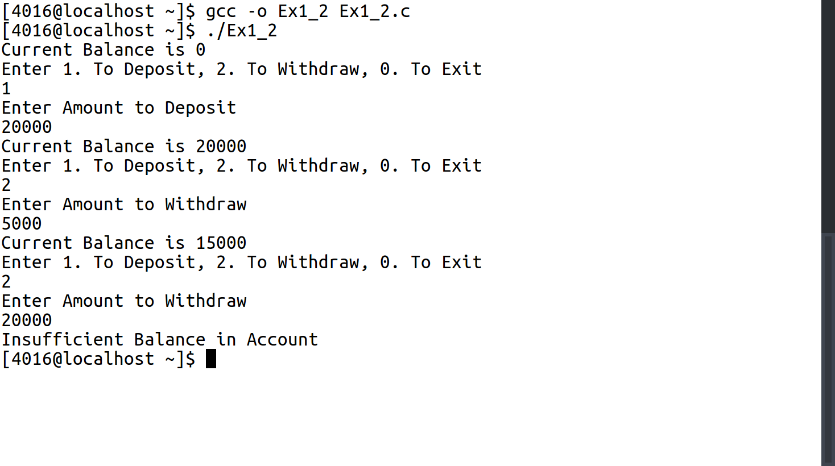

3.

C Program:

1 #include <stdio.h>
2 void triangle();
3 void main(){
4 int row,current;
5 for(row=1;row<=6;row++){
6 for(current=row;current<(2*row);current++){
7 printf("%d ",current);
8 }
9 printf("\n");
10 }
11 triangle();
12 }
13
14 void triangle(){
15 int row,space,current;
16 for(row=1;row<=6;row++){
17 for(space=0;space<(6-row);space++){
18 printf(" ");
19 }
20 for(current=1;current<(2*row);current++){
21 if(current<=row){
22 printf("%d ",current);
23 }
24 else{
25 printf("%d ",(2*row)-current);
26 }
27 }
28 printf("\n");
29 }
30 }

Input/Output:
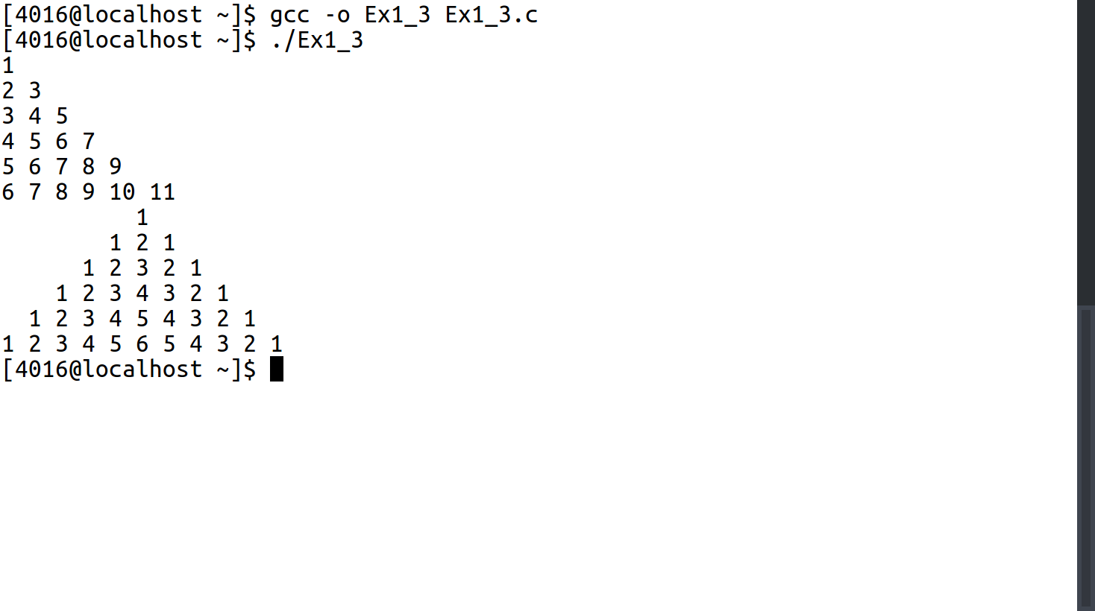

4.

C Program:

1 #include <stdio.h>
2 #include <string.h>
3 void main(){
4 int entry=1,select,quant=1,choice;
5 long int sum=0;
6 char grocery[3][3][30]={{"Apple","Orange","Grape"},{"Laptop","Smartphone","Camera"},{"Soap","Lotion","Cream"}};
7 int prices[3][3]={{10,20,30},{50000,20000,100000},{200,1200,3000}};
8 while (entry==1){
9 printf("1. Fruits, 2. Electronics, 3. Cosmetics\n");
10 scanf("%d",&choice);
11 switch(choice){
12 case 1:
13 printf("1. Apple , 2. Orange, 3. Grape: ");
14 scanf("%d",&select);
15 switch(select){
16 case 1:
17 printf("How Many: ");
18 scanf("%d",&quant);
19 sum+=quant*prices[0][0];
20 break;
21 case 2:
22 printf("How Many: ");
23 scanf("%d",&quant);
24 sum+=quant*prices[0][1];
25 break;
26 case 3:
27 printf("How Many: ");
28 scanf("%d",&quant);
29 sum+=quant*prices[0][2];
30 break;
31 }
32 break;
33 case 2:
34 printf("1. Laptop , 2. Smartphone, 3. Camera: ");
35 scanf("%d",&select);
36 switch(select){
37 case 1:
38 printf("How Many: ");
39 scanf("%d",&quant);
40 sum+=quant*prices[1][0];
41 break;
42 case 2:
43 printf("How Many: ");
44 scanf("%d",&quant);
45 sum+=quant*prices[1][1];
46 break;
47 case 3:
48 printf("How Many: ");
49 scanf("%d",&quant);
50 sum+=quant*prices[1][2];
51 break;
52 }
53 break;
54 case 3:
55 printf("1. Soap , 2. Lotion, 3. Cream");
56 scanf("%d",&select);
57 switch(select){
58 case 1:
59 printf("How Many: ");
60 scanf("%d",&quant);
61 sum+=quant*prices[2][0];
62 break;
63 case 2:
64 printf("How Many: ");
65 scanf("%d",&quant);
66 sum+=quant*prices[2][1];
67 break;
68 case 3:
69 printf("How Many: ");
70 scanf("%d",&quant);
71 sum+=quant*prices[2][2];
72 break;
73 }
74 break;
75 }
76 printf("1. Continue 2.Checkout");
77 scanf("%d",&entry);
78 }
79 printf("Your Total Amount is : %ld\n",sum);
80
81 }

Input/Output:
